***Assignment 1:***

Relative vs Absolute positioning in css:

Both are types of positioning methods.

In simple terms, a relative position puts an element in a position that is relative to its current position or normal position, without altering the layout around it or displacing elements. i.e. other elements will not undergo adjustments to fit into gaps caused by the relative position. Whereas an absolute position specifies the position of the element relative to the position of its parent or ancestor, therefore, altering the position of elements around it accordingly.

Css box sizing and more precisely Margin vs Padding:

All elements can be considered to be boxes. Box sizing allows the addition of borders around elements and to specify the spaces separating elements. In that context, 4 characteristics are to be defined: the content, the padding, the borders and the margins. They are shown in the figure below.

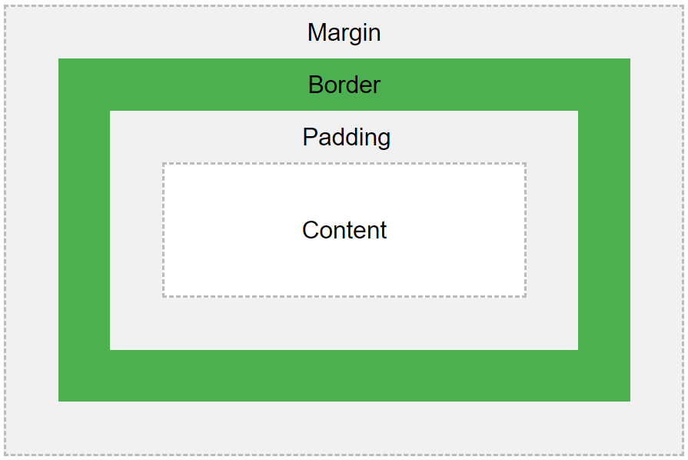

The border is a visible parameter here. Both padding and margin are transparent. The former clears an area around the content, or inside the element, whereas the latter clears an area around the borders or around the element.

Padding is mainly used to make a block or button bigger regardless of the contents size, or to add space between the content and the borders.

Margins are mainly used to define the space between elements.